Basic Principle
Construction:
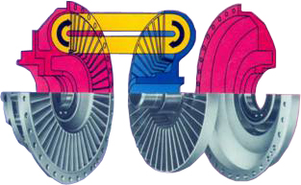
Fluidomat fluid couplings work on the hydrodynamic principle. It consists of a pump-generally known as impeller and a turbine generally known as rotor, both enclosed suitably in a casing. The impeller and the rotor are bowl-shaped and have large number of radial vanes. They face each other with an air gap. The impeller is suitably connected to the prime mover while the rotor has a shaft bolted to it. This shaft is further connected to the driven machine through a suitable arrangement. Oil is filled in the fluid coupling from the filling plug provided on its body. A fusible plug is provided on the fluid coupling which blows off and drains out oil from the coupling in case of sustained overloading.
Operating principle:
There is no mechanical interconnection between the impeller and the rotor (i.e. the driving and driven units) and the power is transmitted by virtue of the fluid filled in the coupling. The impeller when rotated by the prime mover imparts velocity and energy to the fluid, which is converted into mechanical energy in the rotor thus rotating it.
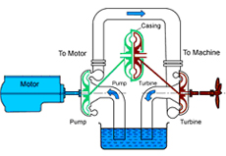

The fluid follows a closed circuit of flow from impeller to rotor through the air gap at the outer periphery and from rotor to impeller again through the air gap at the inner periphery. To enable the fluid to flow from impeller to rotor it is essential that there is difference in the "head" between the two and thus it is essential that there is difference in R.P.M., known as slip between the two. Slip is an important and inherent characteristic of a fluid coupling resulting in several desired advantages. As the slip increases more and more fluid can be transferred from the impeller to the rotor and more torque is transmitted. However when the rotor is at standstill, maximum fluid is transmitted from the coupling. The maximum torque is limiting torque. The fluid coupling also acts as a torque limiter.

Characteristics:
Fluidomat fluid coupling has centrifugal characteristics during starting, thus enabling no load start-up of prime mover, which is of great importance.
The slipping characteristics of fluid coupling provides a wide range of choice of power transmission characteristics which also result in speed variation, smooth & controlled acceleration, clutching and declutching operations and other characteristics of load limiting shock & peak load absorption and dampening etc. By varying the quantity of oil filled in the fluid coupling, the normal torque transmitting capacity can be varied. The maximum torque of the fluid coupling can also be set to a pre-determined safe value by adjusting the oil filling.
The fluid coupling has the same characteristics in both directions of rotation.
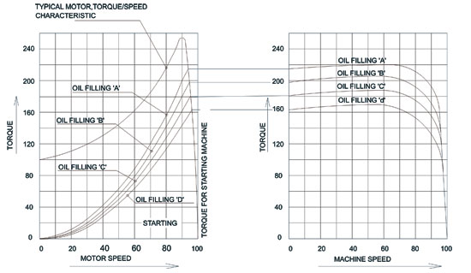
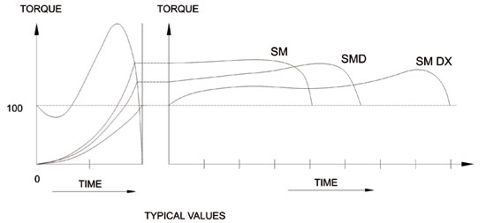
Scoop Control Variable Speed Couplings :
These coupling have a sliding scoop tube which enters the coupling rotating casing through central clearance. The oil quantity level in the coupling can be varied which in operation by changing the position of the scoop tube which determines the oil level in the coupling. This change of oil level shifts the torque characteristic of the coupling thus enabling step less speed control .See the characteristic curve shown below.
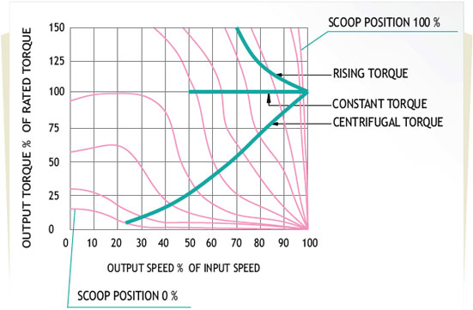
Important Oil Properties:
Kinematic viscosity : 40 Deg.
Viscosity Index : 95
Flash Point : 190 Deg.
Equivalent Oils:
IOC | SERVO SYSTEM 32 | ESSO | TORQUE FLUID N45
BP | ENERGOL HLP 32 | GULF | HYDRAULIC OIL 32
CALTEX | TORQUE FLUID 32 | SHELL | TOGULA OIL 32
CASTROL | HYPSIN AWS 32 | MOBIL | MOBIL FLUID 124

